AI Gateway To Commerce

Applies to: Dynamics 365 Commerce, Dynamics 365 Customer Service, Dynamics 365 Finance, Dynamics 365 Sales, Dynamics 365 Supply Chain Management, Power Automate, Power Apps, Power Pages, Azure App Service, Azure Active Directory…
This solution enables business users to talk to Commerce using AI.

Introduction
The introduction section should describe the solution at a high level and answer the following questions.
- The architecture can be referred to AI integration with D365 Commerce and further can be enhanced to integrating more Commerce and Third Party Apis to copilot.
- This reference architecture reflects the foundation of MCP servers for commerce. It should be used to refer during the design and development phase of the project.
- The key stakeholders required for the architectures are technical architects, solution architects and customer implementation owners.

Architecture
The following diagram illustrates the architecture for the solution.
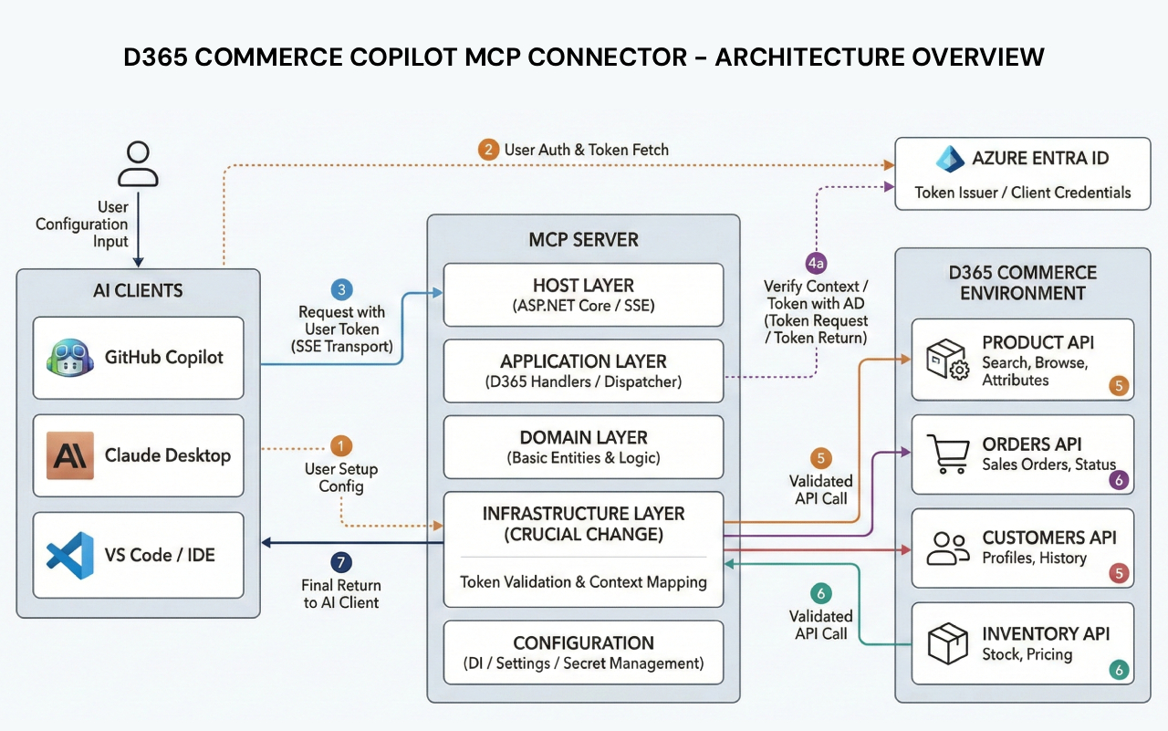

Workflow

Step 1 — Business User Asks in Plain English A business manager types a question in their AI assistant (Copilot): "Show me all open orders for customer Contoso Ltd."

Step 2 — Copilot Sends to MCP Connector The AI assistant recognizes it needs live data and forwards the request to the D365 Copilot MCP Connector via the MCP/SSE transport layer.

Step 3 — MCP Connector Identifies the Right Tool The Application layer parses the intent and routes it to the correct MCP Tool Handler — in this case, the Orders tool.

Step 4 — Azure AD OAuth2 Authentication Before touching any D365 data, the Infrastructure layer requests a secure Bearer token from Azure AD using Client Credentials flow. No token = no data.

Step 5 — D365 Commerce API Call With a valid token, the connector calls the D365 Commerce Orders API — passing filters like customer name, order status, and date range.

Step 6 — D365 Returns Live Data D365 Commerce responds with the raw order data — order numbers, statuses, amounts, dates.

Step 7 — MCP Connector Formats the Response The Domain layer processes the raw response into a clean, structured format the AI model can understand.

Step 8 — AI Model Composes the Answer The AI receives the structured data and composes a natural language response, not raw JSON, but a readable, conversational answer.

Step 9 — Business Manager Gets the Answer Back in the chat interface, the manager sees: "Contoso Ltd has 3 open orders: SO-1042 ($4,200), SO-1051 ($1,800), SO-1063 ($9,500). The oldest is 12 days old."

No dashboards visited. No API docs consulted. No context switching. Just an answer.

Reference PPTx

Components
The following components are used in the reference architecture.
1. AI Client Layer
- Copilot
- Any MCP-compatible AI client
- MCP/SSE transport protocol

2. D365 Commerce MCP Connector – Sample code loaded in github
- Host Layer — ASP.NET Core web host, SSE endpoint, request pipeline
- Application Layer — MCP Tool Handlers (Products, Orders, Customers, Inventory etc.
- Domain Layer — Core business entities, D365 data models, response formatters
- Infrastructure Layer — D365 Commerce HTTP clients, token management, API call
- Configuration Layer — Dependency injection, app settings, environment config

3. Security & Identity
- Azure AD App Registration (Client ID + Secret)
- OAuth2 Client Credentials flow
- Bearer token acquisition & caching
- Scopes & API permissions to D365

4. Microsoft Dynamics 365 Commerce
- D365 Commerce environment URL

5. Infrastructure & Hosting
- .NET 9 SDK runtime
- App hosting —Azure App Service
- NuGet packages — MCP SDK, Azure.Identity, HttpClient
- appsettings.json — D365 base URL, Azure AD credentials
- NuGet.config — package sources

6. Developer Tooling
- Visual Studio

Scenario details

Every D365 Commerce implementation I've worked on has the same hidden problem. The data is there, the insights are there, but getting to them requires navigating a ten different screens, reports, and dashboards that most business users simply don't have time for. AI assistants are powerful, but you can leverage them more productively by giving some context and secure channel to enterprise data.

The D365 Commerce MCP Connector bridges that gap. It connects AI assistants directly to Dynamics 365 Commerce through the Model Context Protocol. Enabling plain-English queries against live products, orders, customers, and inventory data and many more, secured via Azure AD OAuth2. The result is faster decisions, less context switching, and AI that actually knows what's happening in your business right now.

Potential use cases
This solution was created for a retail business but can also be applied to subsegment of wholesales clubs, grocery markets etc. The concept can also be applied to other modules of D365 or third party applications by identifying the right platform for integration.
You can use this solution to:
- Retail & Wholesale
- Third party applications
- Warehousing & Fulfillment

Considerations
These considerations help implement a solution that includes Dynamics 365 Commerce, MCP and Copilot. Learn more at zubair1599/D365CopilotMCPConnector: D365Commerce MCP

Cost optimization
Since the solution requires hosting, it doesn’t have any significant cost but main cost lies in copilot messaging. Please refer to below link for breakdown of copilot licenses and messaging cost.
Plans for GitHub Copilot - GitHub Docs

Deployment
The solution deployment require Azure App services to host MCP server which will talk to Commerce Scale Unit hosted in client tenant. Rest is all configurations.
Below sections are not applicable at this stage of the project.

Implementing [name of solution]
NA

Procedure: [Name of procedure]
- NA

Next step
- NA

Related patterns
- Model Context Protocol

Related resources

What is the Model Context Protocol (MCP)? - Model Context Protocol
zubair1599/D365CopilotMCPConnector: D365Commerce MCP

Tags
Industries: Wholesale Trade, Retail Trade, AI
Stakeholders: Accounts payable, Accounts receivable, Administrative, Audit, Customer services, Finance, IT, Marketing, Merchandising, Operations, Purchasing, Retail store operations, Sales, Service operations, Transportation, Warehouse
Products: D365 CoPilot, MCP, Dynamics 365 Commerce, Dynamics 365 Customer Service, Dynamics 365 Finance, Dynamics 365 Sales, Dynamics 365 Supply Chain Management, Power Automate, Power Apps, Power Pages, Dataverse, Azure Logic Apps, Azure Functions, Azure Data Lake, Azure Synapse, Azure Key Vault, Azure SQL Database, Azure Active Director

Contributors
Principal author: Muhammad Zubair
Other contributors:

